**User Guide**

# 1. Introduction

Welcome to our Unity-based driving simulation game designed for research purposes. This simulation aims to help studying the "Post Error Slowing” phenomenon by introducing controlled errors during gameplay. As you navigate through various tracks, the game will record detailed data on your interactions, movements, and kinematic reactions to these errors.

# 2. Getting Started

To start the game, launch the Unity Executable called *“Driving Simulation”* located inside the *“Driving Simulation System”* folder.

Wait for the game to load and the Main Menu page to be presented on screen. Press the *Play* button to start a game session.

Once a session has started, the system will automatically begin tracking data.

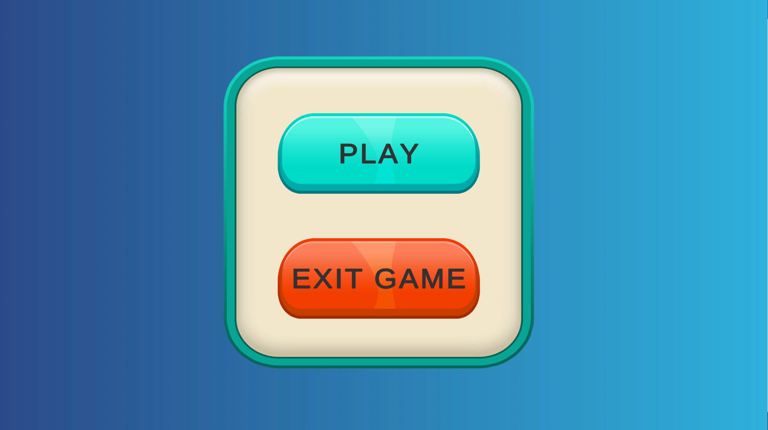

*The Main Page of the system – start the game or close it.*

# 3. Gameplay Overview

The game consists of 5 levels or “tracks”.

Players control a car using the arrow keys to navigate through these tracks.

In each track, there are 5 bridges under which the car will be momentarily hidden from view. During these moments that controlled errors, in the form of unexpected directional shifts, may occur.

The tracks are visually the same, but each track has a different *Error Magnitude*. For e.g., Track_1 has an error magnitude of 5% while Track_3 has an error magnitude of 60%.

The Error in each track is scattered pseudo-randomly between the 5 bridges. For e.g., the controlled error in Track_1 will occur in bridge 3 while in Track_2 the controlled error will occur in bridge 5.

# 4. Interacting with the Game

* Use the **Arrow Keys** to steer the car through the track.
* Press the arrow keys in a certain direction and the car will move to it.
* When approaching a turn, press ***only the arrow key in that direction*** and the car will turn automatically and adjust to the angle of the turn:



*Steering turns by pressing only one arrow key at a time.*

* Press **both arrow keys (left + top/bottom or right + top/bottom)** simultaneously to perform slight directional movement in the direction wanted:



*Steering turns by pressing two arrow keys at a time.*

* **Escape key (‘Esc’)** may be pressed at any point while the game runs to stop the current session and go back to the Main Menu page (Fig 1)

# 5. Data Collection

Throughout the gameplay, the following data will be collected in intervals of *0.02* seconds:

* **User Inputs:** Which arrow keys were pressed in each interval.
* **Car Kinematics:** Velocity and Acceleration Vectors (2D vectors - X and Y axis directions), including their magnitudes.
* **Error and Bridge indication:** Each data sample also mentions if the input collected in that sample is input captured prior and after to the car entering a hidden view under a bridge in the track, and whether a controlled error occurred in that bridge.
* **Error Magnitudes:** What was the error magnitude and in what bridge it occurred in each of the tracks.

The data is saved in a designated folder called *“Logs”*. Each game session is saved in a different folder within it.

The name of the folder per game session is the Time Stamp (date and hour) the game session has started:

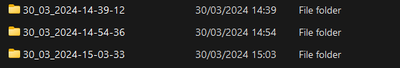

The contents of each game session data and corresponding error magnitudes are saved in CSV files:

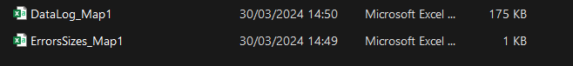

The data sampled from a track:

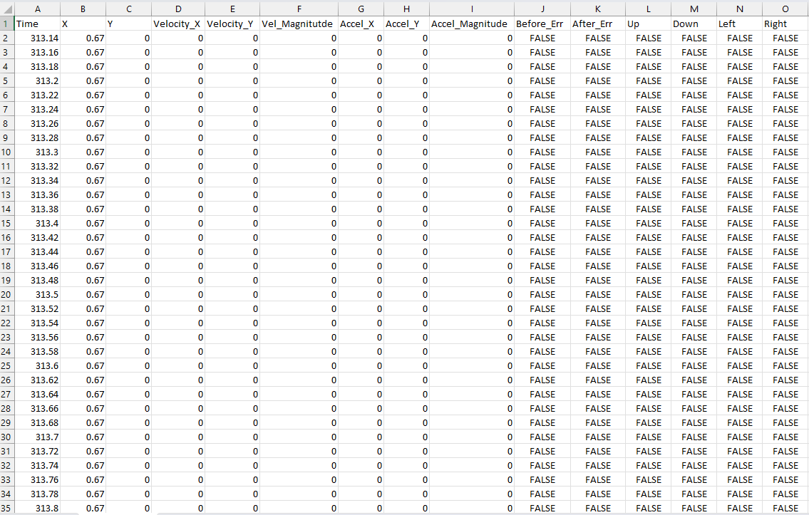

The controlled error magnitude (10% deviation in the left direction from the current position of the car) and location:

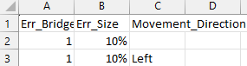

# 6. Data Analysis

To analyze the raw data collected in the log files, we need to create a CSV file called “Insights” log. This log will be read by the Python script that will output the charts of the results regarding the error detection thresholds.

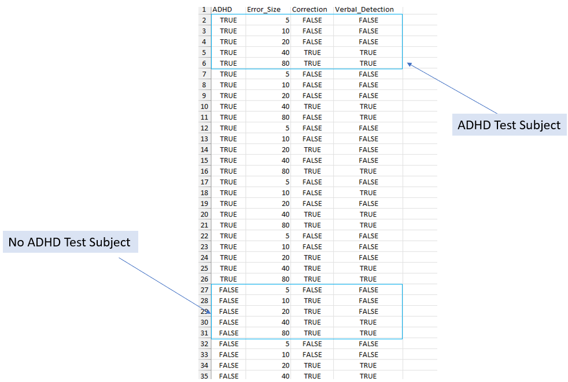

The above image is an example of the structure of the file as it needs to be. Each set of 5 rows represents a user session.

1. **ADHD** – fill in ‘TRUE’ or ‘FALSE’ if the user data is of a user diagnosed with ADHD or not.
2. **Error_Size** – fill in the error size you analyzed. (the error is logged in the “ErrorSizes” CSV log)
3. **Correction** – fill in ‘TRUE’ if the player corrected the error in the game. Each error location is logged in the “ErrorSizes” log which refers to a specific “Data” log:

* Open the ErrorSizes log and locate the corresponding error location.
* Open the Data map that ErrorSizes refers to (for e.g., ErrorSizes_Map1 refers to DataLog_Map1 In the folder)
* Locate the relevant index of the bridge in which the error occurred in, to do so you must count the number of ‘TRUE’ groups in the “After_Err” column in the DataLog log. For example, if the error occurred in the 3rd bridge, then you must count 2 sets of ‘TRUE’ values in the “After_Err” column. The first appearance of a true value in the column after counting 2 previous sets of true values, indicates that the following set of true values represent the time frame whom the user may or may not correct the error.
* Check if the user pressed two arrow keys simultaneously – one key must be a top/bottom key and the other must be a left/right.
* **Verbal Detection** – fill in ‘TRUE’ or ‘FALSE’ if the user verbally declared he saw a deviation after exiting the bridge when an error occurred.

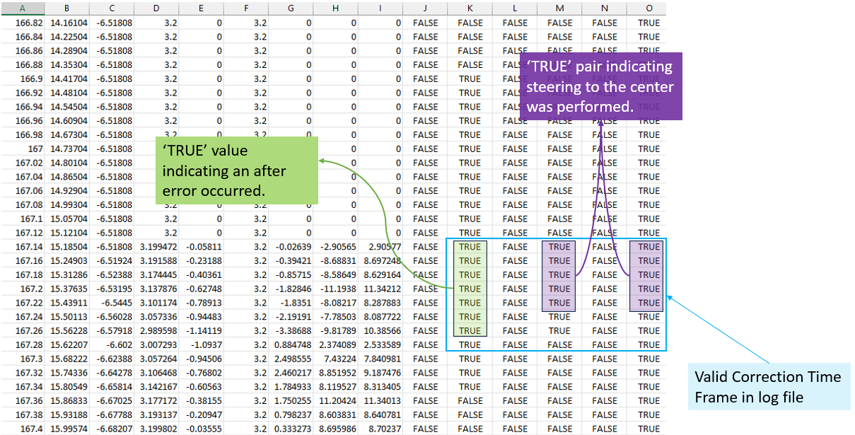

The above image shows an example of a user who corrected the errors.

Lastly, open the Python script named “*insights_analysis.ipynb*” in Google Collab, upload the Insights log to the collab environment as instructed by Google’s documentation, run the script, and the results will be calculated and visualized in charts.

For velocity and acceleration mean calculations per bridge and per error size in each bridge – divided into two categories of test subjects with ADHD and test subjects without ADHD you must follow the instructions below (it is recommended to create a hard copy of the folder before any changes done!):

1. Change the name of the session folders within the Logs folder from a timestamp folder name to ADHD<#incerement index> or NO_ADHD<#incerement index> respectively if the folder contains log files of a user diagnosed with ADHD or not. For e.g., ADHD1, ADHD2, NO_ADHD1, NO_ADHD2 etc.
2. Compress the folder to a ZIP file.
3. Open Google Collab and mount your Google Drive to it.
4. Open the Python script named “*mean_analysis.ipynb*” in Google Collab upload the Insights log to the collab environment as instructed by Google’s documentation, run the script, and the results will be calculated and visualized in charts.
5. The script will output 4 folders categorizing the calculated metric per test group:

* Adhd-vel-avg
* Adhd-accel-avg
* No-adhd-vel-avg
* No-adhd-accel-avg

These folders will be saved in your mounted google drive.

Each folder will contain 10 CSV files –

* 5 files named “bridge1.csv”, “bridge2.csv”, etc. Each file contains the mean calculations of the metric (velocity or acceleration) of the error that may or may not be induced in that bridge for the users.
* 5 files named “bridge1_changes.csv” etc. Each file indicating changes in that metric per error size relative to the “normal” behavior – the “0% error size” calculated in the mean calculation files.

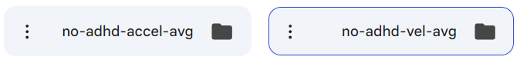

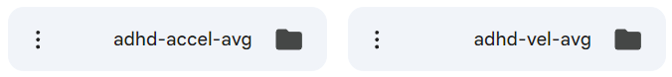

Example of the content of the folders (bridge 5 calculations – the other files from 1 – 4 are also present in the folder) :

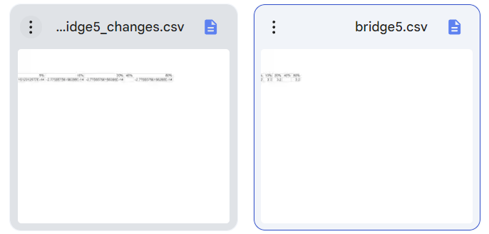

Example of the “bridg2.csv” contents for acceleration metric:



And example of the “bridge2_changes.csv” corresponding to that file:



Note: Positive values indicate an increase in speed or acceleration and negative values indicates a decrease.